Synopsis

Behavioral Segmentation for Targeted Marketing

Problem Id: 10

Student Name- Aditya Dutta
University Roll number- 2028623
Section- U

Student Name- Himanshu Kumar
University Roll number- 2028428
Section- U

Student Name- Akash Kumar
University Roll number- 2028629
Section- U

- Problem Description:
In today’s market, businesses need to understand their customers better to offer the right products and services. This project focuses on grouping customers based on their buying behavior using a machine learning technique called K-Means clustering. The aim is to identify different types of customers, also known as customer segments or personas.
Before applying the algorithm, the data is scaled using StandardScaler so that all features are treated equally and no single value dominates the results. The Elbow Method is then used to find the most suitable number of clusters for accurate segmentation.
By dividing customers into meaningful groups, businesses can create more targeted marketing strategies, improve customer experience, and increase overall sales. This type of analysis is commonly used in real-life scenarios such as online shopping platforms, retail businesses, and digital marketing systems, where understanding customer behavior plays a key role in decision-making.

- Steps of Implementation:

- Data Synthesis
First, a dataset of 150 customers is created using Python. It includes simple features like how much a customer spends in a year (Annual Spending) and how often they make purchases (Purchase Frequency).
- Data Preprocessing
Next, the data is prepared for analysis. Any inconsistencies are handled, and the values are scaled using StandardScaler so that all features are on the same level and give fair results.
- Model Training
After preprocessing, the K-Means clustering algorithm is applied. This model helps in grouping customers based on similarities in their spending behavior.
- Optimal Cluster Selection
To decide how many groups should be formed, the Elbow Method is used. It helps in selecting the most suitable number of clusters for better accuracy.
- Cluster Assignment
Once the model is trained, each customer is assigned to a specific group or cluster based on their behavior.
- Visualization
Finally, the results are displayed using scatter plots, making it easier to understand and interpret the different customer segments.

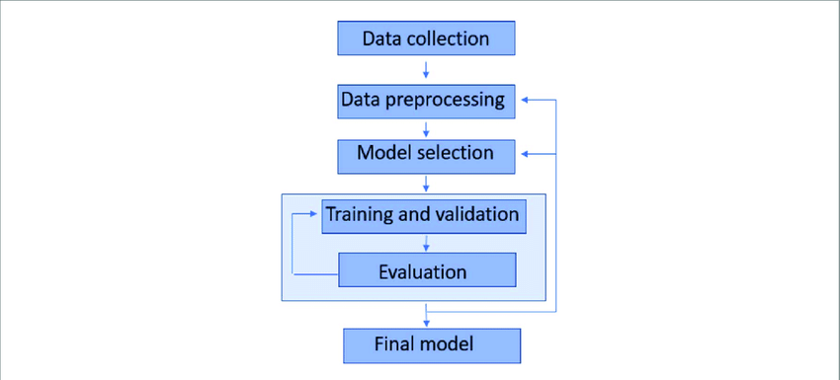
- Expected Modules/ Libraries to be used :
- NumPy
Used for working with numbers and generating random data for the dataset.
- Pandas
Helps in organizing and managing the data in a table format (DataFrame), making it easy to analyze and modify.
- Matplotlib
Used to create graphs and charts, which help in visualizing customer segments clearly.
- Scikit-learn
Provides useful machine learning tools like StandardScaler for scaling the data and K-Means for grouping customers into clusters.

- Expected Evaluation metrics and Plots to be used:
- Elbow Method (WCSS)
This method is used to decide the ideal number of customer groups. It helps in finding a balance so that the clustering is neither too simple nor too complex.
- Scatter Plot
Scatter plots are used to visually represent the data, making it easy to see how customers are grouped into different segments.
- Cluster Visualization
By visualizing the clusters, we can better understand different customer behavior patterns, such as high spenders, frequent buyers, or occasional customers.

- Required topics from the subject:
- Arrays / Lists
Used to store and manage the dataset values in an organized way so they can be easily processed.
- File Handling
Helps in reading data from files and saving the dataset (like CSV files) for future use.
- Functions
Used to divide the program into smaller, reusable parts, making the code easier to understand and manage.

- Platform Required:

The project will be developed using the Python programming language. The implementation and testing of the model will be carried out in Jupyter Notebook within the Anaconda environment. These tools provide a simple and interactive platform for writing code, performing data analysis, training machine learning models, and visualizing the results effectively.

- Books and Link Sources:

- Scikit-learn Official Documentation : https://scikit-learn.org
This website provides detailed information and examples for implementing machine learning models.

- Pandas Official Documentation: https://pandas.pydata.org
This resource is helpful for understanding how to work with datasets and perform data manipulation in Python.

- Behavioral Segmentation for Targeted Marketing Dataset: www.chatgpt.com

